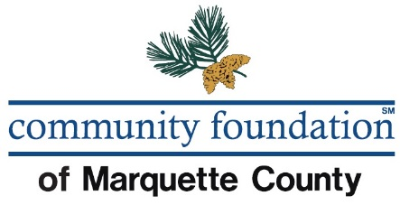

Scholarship Application

PLEASE NOTE THAT THE DEADLINE FOR RECEIPT OF THE SCHOLARSHIP APPLICATION is
__________, 2019.

NAME: _____________________________________________________________________
Last First Middle

CURRENT ADDRESS: __________________________________________________________
PHONE NUMBER: __________________________

FATHER’S NAME: ____________________________________________________________
Last First Middle

MOTHER’S NAME: ___________________________________________________________
Last First Middle
SCHOOL: _________________________________
NAME OF COLLEGE OR UNIVERSITY WHICH YOU PLAN ON ATTENDING: _________________

Have you been accepted by the school or college? YES ______ NO_____
What program do you plan to pursue? ___________________________________________
Are you the first in your family to attend college/university? YES_____ NO_____

I hereby authorize release of information from my school records, including test scores, to the Scholarship Committee.
Student Signature: ________________________________

Parent’s Signature: ________________________________
If student is under 18

Date: _______________________

DO NOT WRITE BELOW THIS LINE

Rank in class ____ / ____ G.P.A. _____________
High School Course of Study ___________________________________________________

School Acceptance Verified YES _____ NO _____ PENDING _____

List those classes you have taken during your high school career that relate to the scholarship required field (i.e. nursing, science, health) and the grades that you received for those classes:

____________________________________________________________________________________________________________________________________________________________________________________________________________________________________________________________________________________________________________________________

Write a short statement as to why you have applied for this scholarship and indicate how you have demonstrated good citizenship in your school and community.

________________________________________________________________________________________________________________________________________________________________________________________________________________________________________________________________________________________________________________________________________________________________________________________________________________________________________________________________________________________________________________________________________________________________________________________________________________________________________________________________________________________________________________________________________________________________________________________________________________________________________________________________________________________________________________________________________________________________________________________________________________________________________________________________________________________________________________________________________________________________________________________________________________________________________________

__________________________________________
Signature Date

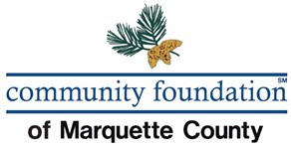

Below is a listing of the scholarships administered by the Community Foundation of Marquette County (CFMC) and eligibility criteria. Please check off any scholarships as long as you meet the qualifications. Complete the application, any additional required documents, and return to CFMC by the deadline as listed on p.1.

Marquette County Scholarships:

- Bernadette Reider Scholarship
Graduating seniors of a high school in Marquette County who will be pursuing certification or a degree at an institution of higher education in the field of nursing.

- Mark Ulrickson Memorial Scholarship
Graduating seniors of one of the high schools in Marquette County who will be enrolled in a college or university for the continuation of the student's education. Statement of adjusted family income required.
Preference will be given to the eligible applicants based on the following:
- Financial need, especially if the student is the first in their family to attend college,
- Participation in the Big Brothers/Big Sisters program,
- Students pursuing higher education at Northern Michigan University.

Ishpeming/Westwood/Negaunee Scholarships:

- Stuart L. Sundblad Memorial Scholarship
Graduating seniors of Ishpeming High School or Westwood High School who will be attending Northern Michigan University as a full time student and who has maintained a minimum grade point average of 2.5 . The recipient may not be receiving more than 50% of the tuition fees and costs from scholarships.

- Anna L. Tobin Scholarship
Students of Ishpeming High School pursuing a career in the performing arts; theater or drama, music, dance and singing. If no candidates from IHS qualify, candidates from both Negaunee High School and Westwood High School may be considered. Statement of adjusted family income required.

Statement of adjusted family income
(To be completed by student and parents as applicable.)

During the preceding 12 months, have you (A) resided with, (B) been claimed as a dependent for Federal Income Tax purposes by or been the recipient of an amount in excess of $600.00 from one (or both) of your parents? YES_____ NO_____ (“X” one)
If the answer to the above question is “Yes” (in whole or part), your parent, or both of your parents, if they are living together, must complete and sign this statement of adjusted family income.
Adjusted gross income (from federal tax returns or estimates)
(Please provide a photocopy of your income tax statement for verification purposes.)
This information will remain confidential.
A. Father $_________ Mother $_________ Joint $ __________ Total $__________
B. Student $__________
Total adjusted gross income (add lines A & B) $__________
Enter the total amount of personal exemptions claimed on tax return:_____
Signature of person completing financial statement:
____________________ ____________________
Father Mother
------------------------------------------------------------------------------------------------------------
Are any of the other family members presently attending college?
YES_____ NO_____ If yes, Please name______________________________________
Have you applied for other financial aid? YES_____ NO _____
If yes, please list____________________________________________________
Will you be eligible for:
Social Security | YES |  | NO |  | Possibly
Veterans Benefits | YES |  | NO |  | Possibly
Vocational Rehabilitation | YES |  | NO |  | Possibly
Other | YES |  | NO |  | Possibly

List Other____________________________________________________

