Bes t Practices for a YAC Member: Thank you for your interest in the Community Foundation’s Youth Advisory Committee (YAC)! Please review the ‘best practices’ in this application to see if the YAC might be a good fit for you. Also note that the average length of service is 3-4 years, during which YACers commit to meet monthly. Occasionally additional meetings are required as is participation in special fundraising or community volunteer events as the Committee determines together. An annual Youth Grantmakers Leadership conference is not required but is a wonderful opportunity for YAC members.

Application:
Please fill out the application sheet. You may attach a page, if necessary.

By mail to:

Community Foundation of Marquette County
Youth Advisory Committee
PO Box 37
Marquette, MI 49855

Or by email to our parent advisor
info@cfofmc.org

Each applicant will receive an email acknowledging their application, and its acceptance or declination. Final selections will be made promptly. Thank you again for your interest!

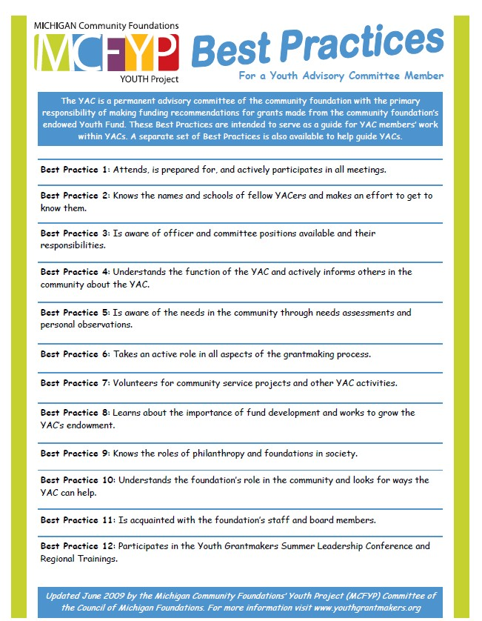

Name:__ Age:_

Home Address:____ (Number & Street) (City) (State) (Zip)

Phone: (____) Email:____ Male___ Female___ Parent(s)/ Guardian(s) name(s):_

School:__
Grade:___ _

- Share something you’ve been a part of that had an impact on you.

- If you had $1,000, how would you invest in local organizations to improve the quality of life for the youth of Marquette?

- What do you hope to gain from serving on the YAC?

- What would you consider a weakness that you’d like to work on?

- How do you communicate best? (For an example, small groups, one-on-one, larger groups)

Applicant’s Signature:______ Date:____

Parent’s/ Guardian’s Signature:______ Date:____ _

(Note: If submitted virtually, signatures are not required. Type the required information.)
By signing above I acknowledge that being a member of the Youth Advisory Committee requires a time commitment involving attending monthly meetings. It also involves occasional meetings and/or training throughout the year. I acknowledge that the information provided in this application is accurate.

